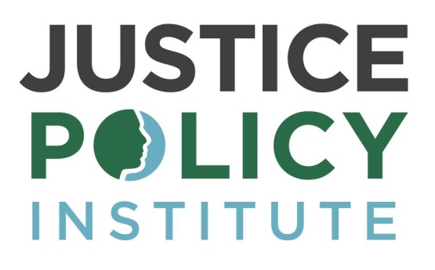
Social Media Toolkit
Raise the Age: Shifting to a safer and more effective justice system

March 7, 2017

Copy and paste these posts to easily share the report! Please use #RaiseTheAge in all posts, tag @JusticePolicy and @JusticeForYouth, and feel free to include the attached charts.

Tweets:
Learn more about the national #JJreform movement to #RaiseTheAge in JPI's newest report with @justiceforyouth! http://bit.ly/2n8yZKX

#RaiseTheAge policies across the country are enhancing public safety & creating a more effective system. Learn more http://bit.ly/2n8yZKX

There's a growing national bipartisan movement to #RaiseTheAge. Read our new report and see for yourself: http://bit.ly/2n8yZKX

Both Democrats and Republicans want to lower crime and save money. Learn how #RaiseTheAge does both: http://bit.ly/2n8yZKX

When young people are kept safe, they’re less likely to reoffend. Read our new report on #JJreform and #RaiseTheAge: http://bit.ly/2n8yZKX

Prisons can be dangerous for adults, let alone youth. Read our new report on why we must #RaiseTheAge http://bit.ly/2n8yZKX

#RaiseTheAge make us safer and heals youth. Learn more about the common-sense initiative in our newest report: http://bit.ly/2n8yZKX

Want a fair and effective #JJreform? Read the latest report on how #RaiseTheAge enhances public safety: http://bit.ly/2n8yZKX

It's time we address the racial gap in corrections. Learn how #RaiseTheAge can close the gap: http://bit.ly/2n8yZKX

Adult jails don't provide education services young people need. #RaiseTheAge, & give kids the treatment they need http://bit.ly/2n8yZKX

FACT: Youth are more at risk for sexual assault in an adult facility. Read our report on why we must #RaiseTheAge: http://bit.ly/2n8yZKX

FACT: Youth are more at risk for mental illness in an adult facility. Read our report on why we must #RaiseTheAge: http://bit.ly/2n8yZKX

FACT: Youth are more likely to be attacked with a weapon in an adult facility. We must #RaiseTheAge, read our report http://bit.ly/2n8yZKX

Local approaches are cost effective and help youth move past delinquency. Learn more of the #RaiseTheAge benefits: http://bit.ly/2n8yZKX

Youths of color are overrepresented in the justice system. Learn how we can increase fairness through #RaiseTheAge: http://bit.ly/2n8yZKX

Youth in adult prison have a harder time transitioning back into their communities. Read our report on #RaiseTheAge http://bit.ly/2n8yZKX

When CT, IL, MA enacted #RaiseTheAge policies, juvenile crime fell and confinement fell. Learn more via http://bit.ly/2n8yZKX

Since CT began #RaiseTheAge they have fewer youths confined and more at-home since. Learn more in JPI’s new report http://bit.ly/2n8yZKX

In NH #RaiseTheAge has appropriated no new money, far below the estimated $5 million. Learn how: http://bit.ly/2n8yZKX

Facebook:

There's a growing national bipartisan movement to #RaiseTheAge. Both Democrats and Republicans want to lower crime, save money, and keep our communities safe. Learn how #RaiseTheAge does all of this, in a new report by the Justice Policy Institute and Campaign for Youth Justice! http://bit.ly/2n8yZKX

Prisons can be dangerous for adults, let alone youth. Youth are more at risk for mental illness and violent attacks when they are in adult facilities. When young people are kept safe, they’re less likely to reoffend. It’s time we have a more fair and effective juvenile justice system, that makes us safer and heals our youth. Learn more about the common-sense initiative in our newest report about #RaiseTheAge: http://bit.ly/2n8yZKX

